
Home

ABOUT US
Four Winds Worldwide Sdn. Bhd. was established in 2001. The company was incorporated with the big names of the industry who have been in the total logistics business for more than 30 years.
Having these prominent and experienced people, Four Winds Worldwide set out to firmly root itself as a global player in International Household Goods Moving and the Commercial cargo business.
In this website, you will see the wealth of experience these individuals bring to the table in the logistics world. Our expertise ranges from International Moving to Ship Chartering, Air Cargo Charter, Project Cargo and e-commerce logistics.
The company appointed Edgar Stephen Pereira as the CEO to head the International Moving division. Edgar who was the founder of AGS Four Winds International in Malaysia, sold his business to AGS France in 2012. Having had a long career in building one of the largest moving companies in Malaysia, he accepted the offer to build Four Winds Worldwide into an international moving company brand after serving his non-competition period.

What sets us apart from our competitors is our approach to international moving of personal & household effects. This is reflected through our very personalized attention to detail on the customers’ requirements. The persons behind each move pride themselves with their experience in the industry, having worked with some of the big names in the industry.

Whatever the moving services might be, no move is too big or too small at Four Winds Worldwide Sdn.Bhd. Request an affordable moving quote today.
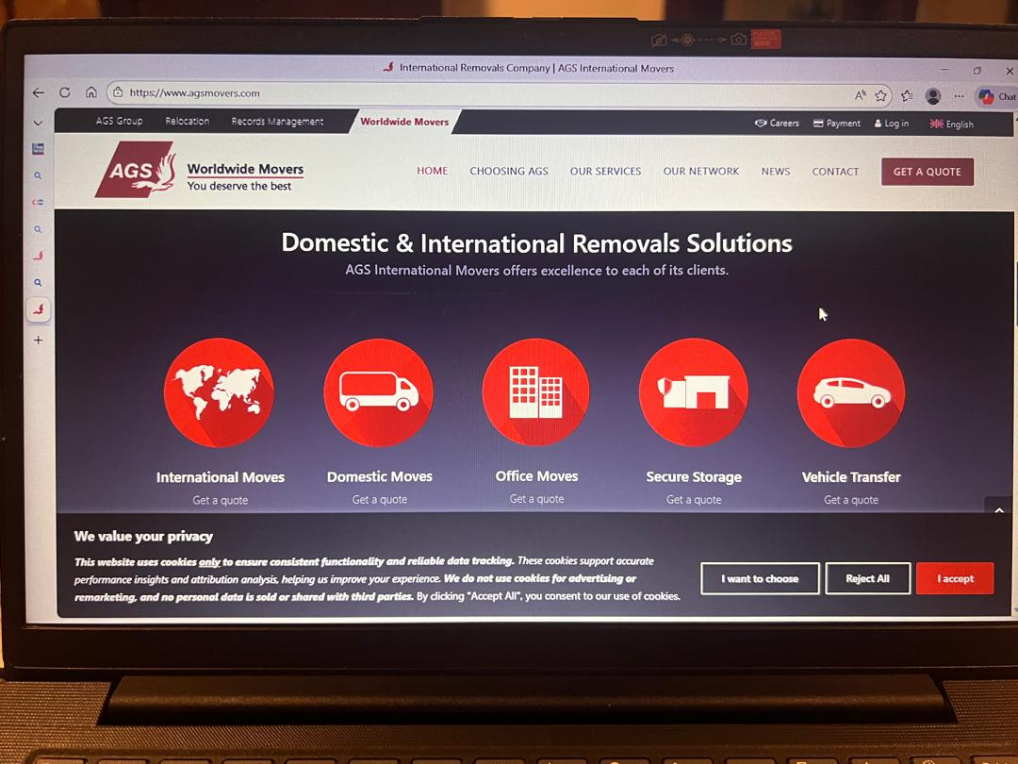

OUR SERVICES….why choose Four Winds Worldwide
International Moving
Four Winds Worldwide has now established itself as a market leader in the moving industry in Malaysia with our network of 1000 international audited and certified agents around the globe. The dedicated team of employees are handpicked experience personal in the moving industry. Most of our staff have in average more than 25 years of moving experience. The wealth of experience and their dedication to manage and coordinate each move with precision is what separates us from our competitors.
We, at Four Winds Worldwide, tailor our international moving services to your unique needs. From pre-move planning at origin to clearing customs at your destination, our team of international movers will make you part of the process every step of the way.
Our approach to international moving is reflected through our very personalized attention to detail on the customers’ requirements. The persons behind each move pride themselves with their experience in the industry, having worked with some of the big names in the industry.
Whatever the moving services might be, no move is too big or too small at Four Winds Worldwide Sdn.Bhd. Request an affordable moving quote today.

